Oral and maxillofacial supportive care for radiotherapy-related xerostomia in head and neck cancer: a systematic review and meta-analysis
Running title: Supportive care for xerostomia
Abstract
Purpose: Radiotherapy-related xerostomia is a frequent oral complication in patients with head and neck cancer. This systematic review and meta-analysis evaluated preventive and therapeutic oral and maxillofacial supportive care interventions for radiotherapy-related xerostomia. Materials and Methods: PubMed/MEDLINE, Scopus and Web of Science were searched for peer-reviewed studies published from 2017 onward. Eligible studies included randomized or controlled clinical studies of interventions for xerostomia or salivary gland hypofunction in head and neck cancer patients treated with radiotherapy. Data were synthesized using a meta-analytic approach, and publication bias was explored by funnel plot. Results: Twelve studies were included. Interventions comprised acupuncture, photobiomodulation, saliva substitutes, oral sprays, mouthwashes, electrical stimulation and honey-based supportive therapy. Most studies showed a favorable direction of effect for xerostomia symptoms, salivary function, swallowing or quality of life. The pooled effect estimate was 1.26 (95% CI: 0.78-1.74), with significant overall effect and moderate heterogeneity (Q(11)=23.16, p=0.017; I²=53.51%). Acupuncture and saliva-substitute or moisturizing products showed the most consistent clinical usefulness, whereas photobiomodulation and electrical stimulation produced more variable findings. Conclusion: Oral and maxillofacial supportive care interventions may help reduce radiotherapy-related xerostomia or improve salivary outcomes in head and neck cancer patients, but the evidence varies by intervention type, timing and outcome measurement. More standardized clinical trials are needed.
Keywords: xerostomia; head and neck neoplasms; radiotherapy; saliva substitutes; meta-analysis
Introduction
Head and neck cancer remains a substantial clinical problem, not only because of tumor-related morbidity but also because treatment may leave long-term oral and functional consequences. Recent global estimates reported 947,211 new cases and 482,428 deaths in 2022 ¹. Radiotherapy is central to the management of many head and neck malignancies, either as definitive therapy, adjuvant therapy after surgery, or combined with chemotherapy. However, radiation exposure to tissues surrounding the tumor can affect the oral mucosa, dentition, swallowing structures, and salivary glands. For this reason, supportive oral care is an important part of survivorship and should be considered alongside tumor control.
Radiotherapy-related xerostomia is among the most frequent and distressing oral adverse effects in this patient group. Xerostomia refers to the subjective feeling of dry mouth, whereas salivary gland hypofunction refers to objectively reduced salivary secretion ². This distinction is clinically relevant because patients may report severe dry-mouth symptoms even when measured salivary flow does not fully explain the complaint. When the parotid, submandibular, or minor salivary glands are within the radiation field, salivary gland damage may occur and can persist after completion of cancer therapy ^{3,4}.
The consequences of xerostomia extend beyond discomfort. Reduced salivary function may contribute to dental caries, oral mucosal soreness, difficulty chewing, impaired swallowing, taste changes, sleep disturbance, poor nutritional intake, and reduced quality of life ⁵⁻⁷. These outcomes place xerostomia within the scope of dental and oral health care rather than only general oncology. For dentists, oral medicine clinicians, and supportive cancer-care teams, prevention and management of radiation-induced dry mouth are therefore practical clinical concerns.
Several approaches have been investigated to prevent or manage radiotherapy-related xerostomia. Preventive strategies include tissue-sparing radiotherapy techniques, radioprotectants, sialogogues, acupuncture, bethanechol, photobiomodulation therapy, and surgical approaches such as submandibular gland transfer in selected cases ^{8,9}. Therapeutic strategies for established xerostomia include pharmacological sialagogues, saliva substitutes, oral moisturizers, mouthwashes, oral sprays, acupuncture, and electrical stimulation ^{2,3,10,11}. These interventions differ in mechanism, timing, burden for patients, feasibility in dental practice, and the outcomes they are most likely to improve.
Previous guidelines and reviews have summarized important evidence, but the literature remains fragmented across different intervention types, outcome measures, and treatment phases. Some studies focus on prevention during radiotherapy, whereas others evaluate chronic xerostomia after treatment. Some report patient-reported xerostomia scores, while others focus on salivary flow, swallowing ability, or quality of life. This variation makes it difficult for clinicians to decide which approach is most relevant for a particular patient.
This systematic review and meta-analysis was conducted to compare the effectiveness of preventive and therapeutic interventions for radiotherapy-related xerostomia in patients with head and neck cancer. For a journal focused on oral and maxillofacial practice, the topic is relevant because xerostomia after radiotherapy affects oral comfort, salivary function, swallowing, caries risk, and quality of life. Compared with reviews that address a single treatment or broad cancer supportive care, this review brings together several preventive and therapeutic approaches and summarizes how their clinical effects may be interpreted for oral and maxillofacial supportive care.
Materials and Methods
Protocol and reporting guideline
This study used a systematic literature review and meta-analysis design. The review was reported with reference to the PRISMA 2020 statement, which provides guidance for transparent identification, screening, eligibility assessment, and inclusion of studies in systematic reviews ¹². The quantitative synthesis followed general principles for combining effect estimates across studies with comparable populations, interventions, comparators, and outcomes ¹³. This review was not registered in PROSPERO.
Eligibility criteria
The review question was structured using the PICO framework. The population was head and neck cancer patients who were undergoing or had undergone radiotherapy, with or without chemotherapy. The interventions were preventive or therapeutic approaches for xerostomia or salivary hypofunction. Comparators included placebo, sham intervention, standard care, standard oral hygiene, no intervention, or another active intervention. Outcomes included xerostomia incidence or severity, dry-mouth symptom improvement, stimulated or unstimulated salivary flow, quality of life, swallowing-related outcomes, and adverse effects. The PICO components are summarized in Table 1.
Information sources and search strategy
PubMed/MEDLINE, Scopus, and Web of Science were searched systematically. The search combined terms for head and neck cancer, radiotherapy, xerostomia or salivary hypofunction, intervention type, and quantitative data suitable for meta-analysis. Searches were limited to peer-reviewed primary articles published from 2017 onward and written in English or Indonesian. The database-specific search results are presented in Table 2.
Study selection and data extraction
Eligible studies were randomized controlled trials, quasi-experimental studies, prospective clinical studies, retrospective comparative studies, or controlled clinical trials involving head and neck cancer patients with radiotherapy-related xerostomia or salivary hypofunction. Studies were included when they evaluated a preventive or therapeutic intervention and reported odds ratios, confidence intervals, p-values, event data, or other data that could be converted into an effect estimate. Reviews, systematic reviews, meta-analyses, scoping reviews, narrative reviews, editorials, letters, protocols, case reports, and case series were excluded.
The selection process included duplicate removal, title and abstract screening, full-text assessment, and final inclusion. Data were extracted on publication year, study design, sample size, intervention, comparator, timing of intervention, xerostomia-related outcomes, salivary flow outcomes, quality-of-life outcomes, adverse effects, and statistical data for effect-size calculation. The study-selection flow is shown in Figure 1.
Quality assessment
The methodological quality of the included studies was considered using key reporting and design indicators relevant to clinical intervention studies, including study design, randomization or allocation approach, blinding, comparator adequacy, outcome clarity, follow-up reporting and completeness of statistical data. The assessment was used to support cautious interpretation of the pooled findings and was not intended to replace study-specific clinical judgment.
Statistical analysis
A fixed-effect model was considered when between-study heterogeneity was low, whereas a random-effects model was used when heterogeneity was clinically or statistically meaningful. Heterogeneity was assessed using the Q statistic and I² value. The pooled effect estimate, confidence interval, and p-value were used to summarize the overall direction and statistical significance of the interventions. Publication bias and small-study effects were explored visually using a funnel plot.
Results
Study selection
The initial search identified 296 records: 96 from PubMed/MEDLINE, 118 from Scopus, and 82 from Web of Science. After removal of five duplicate records, 291 records were screened by title and abstract. At this stage, 224 records were excluded because they were not aligned with the research question, did not involve head and neck cancer patients, did not evaluate radiotherapy-related xerostomia, did not assess preventive or therapeutic interventions, did not provide usable quantitative data, or used an ineligible publication type. Sixty-seven full-text articles were then assessed for eligibility.
During full-text assessment, 55 articles were excluded. The reasons were absence of odds ratios, confidence intervals, p-values, or convertible data in 17 articles; non-specific head and neck cancer populations in eight articles; lack of focus on xerostomia prevention or therapy in nine articles; unclear xerostomia or salivary-flow outcomes in seven articles; ineligible study design in six articles; descriptive data without a comparator in four articles; and unavailable full text in four articles. Finally, 12 articles were included in the qualitative synthesis and meta-analysis.
Characteristics of included studies
The characteristics of the included studies are summarized in Table 3. The highest proportion of studies was published in 2024. Most included studies used randomized controlled or clinical trial designs. The most frequently evaluated interventions were saliva substitutes, oral sprays, mouthwashes, or oral moisturizers, followed by acupuncture. Therapeutic interventions after radiotherapy were more common than purely preventive interventions during radiotherapy. The total sample across the 12 studies was 1,246 patients.
Intervention-level findings
The intervention-level findings are summarized in Table 4. Acupuncture showed a relatively consistent pattern of benefit. Garcia et al. ⁴ reported lower xerostomia scores after true acupuncture compared with standard care, while Cohen et al. ¹¹ found that true acupuncture improved chronic radiation-induced xerostomia and quality of life compared with standard oral hygiene. Menezes et al. ¹⁴ also reported reductions in xerostomia scores and improvements in saliva-related indicators after combined traditional and auricular acupuncture.
Saliva substitutes and moisturizing oral products also showed favorable clinical effects. Nuchit et al. ¹⁵ reported improvements in dry mouth, swallowing ability, and nutritional status with oral moisturizing jelly and topical saliva gel. Marimuthu et al. ¹⁶ found improvements in subjective xerostomia and unstimulated whole saliva after an active saliva-substitute mouthwash. Piboonratanakit et al. ¹⁷ reported improved salivary pH and unstimulated salivary flow after trehalose oral spray, and Rupe et al. ¹⁸ found that sodium-hyaluronate mouthwash reduced xerostomia symptoms and improved patient satisfaction.
Photobiomodulation produced mixed results. Mozaffari et al. ¹⁹ reported higher stimulated saliva and lower subjective xerostomia in the intervention group, whereas Louzeiro et al. ⁹ did not find clear between-group differences for salivary flow, saliva composition, xerostomia, or quality of life. Electrical stimulation also showed variable findings. Paim et al. ²⁰ reported improvements in stimulated salivary flow, self-perceived salivary flow, and quality of life, while Mercadante et al. ²¹ found that intra-oral salivary electrostimulation did not meet its primary and secondary endpoints. Thyme honey was also reported as a safe supportive option that reduced treatment-induced xerostomia in one feasibility randomized controlled trial ²².
Quality assessment findings
Most included studies reported randomized or controlled clinical designs and used active, sham, placebo or standard-care comparators. The strongest methodological reporting was observed in multicenter randomized or double-blind trials, whereas some smaller single-center studies had concerns related to sample size, blinding information, or protocol variability. These differences were considered when interpreting the moderate heterogeneity of the pooled findings.
Meta-analysis findings
The forest plot is shown in Figure 2. Most studies had a favorable direction of effect for reducing xerostomia symptoms or improving salivary function. The pooled effect was 1.26 (95% CI: 0.78-1.74), with t(11) = 5.79 and p < 0.001. Heterogeneity was moderate, with Q(11) = 23.16, p = 0.017, and I² = 53.51%. This indicates that part of the variation across studies likely reflected differences in intervention type, treatment timing, sample size, xerostomia measurement, and residual salivary function.
Publication bias assessment
The funnel plot is shown in Figure 3. Most studies clustered around the central line and within the funnel area, although the distribution was not fully symmetrical. The study by Mercadante et al. ²¹ appeared as the most leftward point, consistent with its non-significant main findings. Because only 12 studies were included, the funnel plot should be interpreted cautiously and should not be used alone to confirm or exclude publication bias.
Discussion
Previous evidence on pharmacological and non-pharmacological options, including amifostine, bethanechol, acupuncture, broader therapeutic interventions, and pilocarpine, has also remained mixed or context-dependent ²³⁻²⁷. This helps explain why xerostomia care after head and neck radiotherapy should not rely on a single standard approach for all patients.
Acupuncture was one of the more consistent non-pharmacological approaches in this synthesis. The findings from Garcia et al. ⁴, Menezes et al. ¹⁴, and Cohen et al. ¹¹ suggest that acupuncture may be useful for both prevention during radiotherapy and management of chronic xerostomia after treatment. This is in line with previous evidence indicating that acupuncture may improve subjective dry-mouth symptoms, although its effect on objective salivary flow is less consistent ^{10,25}. In oral supportive care, this distinction matters because patient-perceived dryness and measured saliva output do not always move in the same direction.
Saliva substitutes, oral sprays, mouthwashes, and oral moisturizers appear especially relevant for day-to-day symptom relief. Their benefits are clinically practical because they target oral comfort, swallowing, and patient satisfaction. These outcomes are important in dental and oral health practice, where the goal is often to help patients maintain eating, speaking, oral hygiene, and mucosal comfort. Compared with interventions that attempt to restore gland function, moisturizers and substitutes may not reverse gland injury, but they can still provide meaningful symptomatic benefit.
Photobiomodulation and electrical stimulation should be interpreted more cautiously. The positive findings from Mozaffari et al. ¹⁹ and Paim et al. ²⁰ indicate potential benefit, but the less favorable results reported by Louzeiro et al. ⁹ and Mercadante et al. ²¹ show that the effect may depend on device type, application site, dose, treatment schedule, timing relative to radiotherapy, and remaining salivary function. These interventions may require more standardized protocols before they can be recommended broadly across clinical settings.
The results also support a phase-based approach to xerostomia care. Preventive strategies during radiotherapy may be most useful when the goal is to preserve gland function and reduce the development of severe dryness. Therapeutic strategies after radiotherapy may be more appropriate when the clinical goal is symptom relief, swallowing comfort, and quality-of-life improvement. This distinction is important for dentists and oral health professionals who often manage patients after oncologic treatment has been completed.
Several limitations should be considered. The included studies varied in design, intervention type, timing, sample size, follow-up duration, and outcome measurement. Some studies reported patient-reported xerostomia scores, while others emphasized salivary flow or quality of life. The relatively small number of included studies also limits the interpretation of funnel-plot asymmetry. Finally, this review compared broad intervention categories; therefore, the findings should guide clinical prioritization rather than replace individualized assessment of each patient.
Future clinical trials should use larger samples, clearer xerostomia definitions, standardized intervention protocols, longer follow-up, and consistent reporting of patient-reported outcomes, salivary flow, quality of life, adverse effects, and effect estimates. For future systematic reviews, more complete reporting would allow stronger subgroup analyses by intervention timing, type of radiotherapy, cancer site, baseline salivary function, and xerostomia severity.
This need for better standardization is also important because xerostomia after head and neck radiotherapy is not a simple single-symptom problem. Radiation may affect several oral tissues at the same time, including the mucosa, teeth, periodontal tissues, sensory function, and salivary glands ²⁸. In the salivary glands, the clinical picture of dry mouth may be related to acinar cell injury, vascular changes, inflammation, fibrosis, and reduced tissue repair capacity after radiation exposure ²⁹⁻³¹. For this reason, future studies and clinical practice should not only measure salivary flow, but also consider oral comfort, swallowing, dental caries prevention, mucosal care, and long-term dental follow-up as part of supportive care for head and neck cancer survivors ³².
Conclusion
Preventive and therapeutic interventions for radiotherapy-related xerostomia in head and neck cancer patients generally showed a favorable direction of effect, with a pooled effect of 1.26 and moderate heterogeneity. Acupuncture and saliva-substitute or moisturizing oral care approaches showed the most consistent clinical usefulness across the included studies. Photobiomodulation and electrical stimulation remain promising but less consistent, and their use should consider protocol, device type, treatment timing, and patient condition.
From an oral and maxillofacial supportive care perspective, xerostomia management should not be standardized as one approach for all patients. Preventive interventions are more relevant during radiotherapy, while therapeutic approaches are needed for persistent dry-mouth symptoms after treatment. Clinical selection should consider xerostomia severity, residual salivary function, oral comfort, swallowing ability, quality of life, feasibility, and patient preference.
Funding
This work did not receive any specific grant from funding agencies in the public, commercial, or not-for-profit sectors.
Acknowledgements
None.
Conflict of interest
The authors declare that they have no conflicts of interest.
Ethical approval
This study is a systematic review and meta-analysis based on previously published studies. No new data were collected from human participants or animals; therefore, ethical approval was not required.
Informed consent
This study did not involve individual participant data, and informed consent was not required.

References
- Sun H, Yu M, An Z, Liang F, Sun B, Liu Y, et al. Global burden of head and neck cancer: epidemiological transitions, inequities, and projections to 2050. Front Oncol 2025;15:1665019. https://doi.org/10.3389/fonc.2025.1665019
- Hong C, Jensen SB, Vissink A, Bonomo P, Santos-Silva AR, Gueiros LA, et al. MASCC/ISOO clinical practice statement: management of salivary gland hypofunction and xerostomia in cancer patients. Support Care Cancer 2024;32:548. https://doi.org/10.1007/s00520-024-08688-9
- Mercadante V, Al Hamad A, Lodi G, Porter S, Fedele S. Interventions for the management of radiotherapy-induced xerostomia and hyposalivation: a systematic review and meta-analysis. Oral Oncol 2017;66:64-74. https://doi.org/10.1016/j.oraloncology.2016.12.031
- Garcia MK, Meng Z, Rosenthal DI, Shen Y, Chambers M, Yang P, et al. Effect of true and sham acupuncture on radiation-induced xerostomia among patients with head and neck cancer: a randomized clinical trial. JAMA Netw Open 2019;2:e1916910. https://doi.org/10.1001/jamanetworkopen.2019.16910
- Jaguar GC, Lima ENP, Kowalski LP, Pellizzon ACA, Carvalho AL, Alves FA. Clinical features and preventive therapies of radiation-induced xerostomia in head and neck cancer patient: a literature review. Appl Cancer Res 2017;37:31. https://doi.org/10.1186/s41241-017-0037-5
- Alnaeem MM, Darwish SK, Nashwan AJ. Radiation-induced xerostomia in head and neck cancers: a comprehensive review for burden and impact on nutrition, sleep, and quality of life. Discov Med 2025;2:143. https://doi.org/10.1007/s44337-025-00362-1
- Nathan CAO, Asarkar AA, Entezami P, Corry J, Strojan P, Vander Poorten V, et al. Current management of xerostomia in head and neck cancer patients. Am J Otolaryngol 2023;44:103867. https://doi.org/10.1016/j.amjoto.2023.103867
- Mercadante V, Jensen SB, Smith DK, Bohlke K, Bauman J, Brennan MT, et al. Salivary gland hypofunction and/or xerostomia induced by nonsurgical cancer therapies: ISOO/MASCC/ASCO guideline. J Clin Oncol 2021;39:2825-43. https://doi.org/10.1200/JCO.21.01208
- Louzeiro GC, Cherubini K, de Figueiredo MAZ, Salum FG. Effect of photobiomodulation on salivary flow and composition, xerostomia and quality of life of patients during head and neck radiotherapy in short term follow-up: a randomized controlled clinical trial. J Photochem Photobiol B 2020;209:111933. https://doi.org/10.1016/j.jphotobiol.2020.111933
- Ni X, Tian T, Chen D, Liu Y, Li H. Acupuncture for radiation-induced xerostomia in cancer patients: a systematic review and meta-analysis. Integr Cancer Ther 2020;19:1534735420980825. https://doi.org/10.1177/1534735420980825
- Cohen L, Garcia MK, Lee R, Haddad R, Lee NY, Chen YH, et al. Acupuncture for chronic radiation-induced xerostomia in head and neck cancer: a multicenter randomized clinical trial. JAMA Netw Open 2024;7:e248725. https://doi.org/10.1001/jamanetworkopen.2024.8725
- Page MJ, McKenzie JE, Bossuyt PM, Boutron I, Hoffmann TC, Mulrow CD, et al. The PRISMA 2020 statement: an updated guideline for reporting systematic reviews. BMJ 2021;372:n71. https://doi.org/10.1136/bmj.n71
- Higgins JPT, Thomas J, Chandler J, Cumpston M, Li T, Page MJ, et al, editors. Cochrane handbook for systematic reviews of interventions. Version 6.5. Cochrane; 2024.
- Menezes AS da S, Sanches GLG, Gomes ESB, Soares RG, Durães CP, Fonseca LL, et al. The combination of traditional and auricular acupuncture to prevent xerostomia and anxiety in irradiated patients with HNSCC: a preventive, parallel, single-blind, 2-arm controlled study. Oral Surg Oral Med Oral Pathol Oral Radiol 2021;131:675-83. https://doi.org/10.1016/j.oooo.2021.02.016
- Nuchit S, Lam-Ubol A, Paemuang W, Talungchit S, Chokchaitam O, Mungkung O, et al. Alleviation of dry mouth by saliva substitutes improved swallowing ability and clinical nutritional status of post-radiotherapy head and neck cancer patients: a randomized controlled trial. Support Care Cancer 2020;28:2817-28. https://doi.org/10.1007/s00520-019-05132-1
- Marimuthu D, Han KM, Mohamad MSF, Azman M. Saliva substitute mouthwash in nasopharyngeal cancer survivors with xerostomia: a randomized controlled trial. Clin Oral Investig 2021;25:3105-15. https://doi.org/10.1007/s00784-020-03634-5
- Piboonratanakit P, Ferreira JN, Pravinvongvuthi K, Maison K, Urkasemsin G, Boonroung T, et al. Trehalose versus carboxymethylcellulose oral spray for relieving radiation-induced xerostomia in head and neck cancer patients: a randomized controlled trial. BMC Oral Health 2023;23:288. https://doi.org/10.1186/s12903-023-02966-4
- Rupe C, Basco A, Gioco G, Patini R, Lucchese A, Miccichè F, et al. Sodium-hyaluronate mouthwash on radiotherapy-induced xerostomia: a randomised clinical trial. Support Care Cancer 2023;31:644. https://doi.org/10.1007/s00520-023-08090-x
- Mozaffari PM, Esmaeilzadeh M, Rahimian S, Shirani AM, Babaei M, Amiri F, et al. Evaluation of the effect of photobiomodulation on radiation-induced xerostomia in head and neck cancer patients: a randomized clinical trial. J Lasers Med Sci 2024;15:e4. https://doi.org/10.34172/jlms.2024.04
- Paim ED, Zanella VG, Martins VB, Macagnan FE, Berbert MCB. Effects of transcutaneous electrical nerve stimulation on the salivary flow of patients with hyposalivation induced by radiotherapy in the head and neck region: a randomized clinical trial. J Oral Rehabil 2019;46:1142-50. https://doi.org/10.1111/joor.12851
- Mercadante V, Hamad AA, McCaul J, Nutting C, Harrington K, Carnell D, et al. Salivary electrostimulation in the treatment of radiation therapy-induced xerostomia (LEONIDAS-2): a multicenter, randomized, double-masked, sham-controlled, phase 3 trial. Int J Radiat Oncol Biol Phys 2024;118:142-53. https://doi.org/10.1016/j.ijrobp.2023.03.047
- Charalambous A, Lambrinou E, Katodritis N, Vomvas D, Raftopoulos V, Georgiou M, et al. The effectiveness of thyme honey for the management of treatment-induced xerostomia in head and neck cancer patients: a feasibility randomized control trial. Eur J Oncol Nurs 2017;27:1-8. https://doi.org/10.1016/j.ejon.2017.01.001
- Gu J, Zhu S, Li X, Wu H, Li Y, Hua F. Effect of amifostine in head and neck cancer patients treated with radiotherapy: a systematic review and meta-analysis. PLoS One 2014;9:e95968. https://doi.org/10.1371/journal.pone.0095968
- Nakamura DM, da Graça Pinto H, Baena Elchin C, Thomazotti Berard L, Abreu Alves F, Azeredo Alves Antunes L, et al. Efficacy of bethanechol chloride in the treatment of radiation-induced xerostomia in patients with head and neck cancer: a systematic review and meta-analysis. Radiother Oncol 2023;186:109715. https://doi.org/10.1016/j.radonc.2023.109715
- Tsai RY, Lin SY, Chen CC, Hsiao Y. Efficacy of acupuncture in managing radiation-induced xerostomia: an updated meta-analysis. Int J Med Sci 2025;22:2802-15. https://doi.org/10.7150/ijms.110366
- Shrateh ZA, Alrabadi N, Abuhammad S, Alomari M. Therapeutic interventions for radiation-induced xerostomia in head and neck cancer patients: a systematic review and meta-analysis. Support Care Cancer 2025;33:1-15.
- Yang WF, Liao GQ, Hakim SG, Ouyang DQ, Ringash J, Su YX. Is pilocarpine effective in preventing radiation-induced xerostomia? A systematic review and meta-analysis. Int J Radiat Oncol Biol Phys 2016;94:503-11. https://doi.org/10.1016/j.ijrobp.2015.11.012
- Sroussi HY, Epstein JB, Bensadoun RJ, Saunders DP, Lalla RV, Migliorati CA, et al. Common oral complications of head and neck cancer radiation therapy: mucositis, infections, saliva change, fibrosis, sensory dysfunctions, dental caries, periodontal disease, and osteoradionecrosis. Cancer Med 2017;6:2918-31. https://doi.org/10.1002/cam4.1221
- Jensen SB, Vissink A, Limesand KH, Reyland ME. Salivary gland hypofunction and xerostomia in head and neck radiation patients. J Natl Cancer Inst Monogr 2019;2019:lgz016. https://doi.org/10.1093/jncimonographs/lgz016
- Wu VWC, Leung KY. A review on the assessment of radiation induced salivary gland damage after radiotherapy. Front Oncol 2019;9:1090. https://doi.org/10.3389/fonc.2019.01090
- Jasmer KJ, Gilman KE, Muñoz Forti K, Weisman GA, Limesand KH. Radiation-induced salivary gland dysfunction: mechanisms, therapeutics and future directions. J Clin Med 2020;9:4095. https://doi.org/10.3390/jcm9124095
- Goh EZ, Beech N, Johnson NR, Batstone MD. The dental management of patients irradiated for head and neck cancer. Br Dent J 2023;234:807-14. https://doi.org/10.1038/s41415-023-5908-z

Tables
Table 1. PICO framework of the review question
Component | Description
P (Population) | Head and neck cancer patients who are undergoing or have undergone radiotherapy, either radiotherapy alone or in combination with chemotherapy.
I (Intervention) | Preventive and therapeutic interventions for xerostomia, such as pilocarpine, cevimeline, bethanechol, amifostine, acupuncture, photobiomodulation therapy, intensity-modulated radiotherapy, saliva substitute, oral lubricant, submandibular gland transfer, and supportive oral care.
C (Comparison) | Placebo, sham intervention, standard care, standard oral hygiene, no intervention, or other comparator interventions.
O (Outcome) | Xerostomia, severity of xerostomia, improvement of dry mouth symptoms, reduction in severe xerostomia, stimulated and unstimulated salivary flow rates, quality of life, and adverse effects of the intervention.

Table 2. Number of articles identified in each database
Database | Keyword | Number of Articles
PubMed/MEDLINE | (“head and neck cancer” OR “head and neck neoplasms” OR “oral cancer” OR “nasopharyngeal cancer” OR “oropharyngeal cancer”) AND (radiotherapy OR radiation OR “radiation therapy” OR chemoradiotherapy) AND (xerostomia OR “dry mouth” OR “salivary hypofunction” OR hyposalivation) AND (pilocarpine OR cevimeline OR bethanechol OR amifostine OR acupuncture OR “photobiomodulation” OR “low-level laser therapy” OR “intensity-modulated radiotherapy” OR IMRT OR “saliva substitute” OR “oral lubricant” OR “submandibular gland transfer”) AND (“odds ratio” OR “confidence interval” OR “p value” OR trial OR intervention) | 96
Scopus | TITLE-ABS-KEY (“head and neck cancer” OR “head and neck neoplasm” OR “oral cancer” OR “nasopharyngeal cancer” OR “oropharyngeal cancer”) AND TITLE-ABS-KEY (radiotherapy OR radiation OR chemoradiotherapy) AND TITLE-ABS-KEY (xerostomia OR “dry mouth” OR hyposalivation OR “salivary gland hypofunction”) AND TITLE-ABS-KEY (pilocarpine OR cevimeline OR bethanechol OR amifostine OR acupuncture OR photobiomodulation OR “low-level laser therapy” OR IMRT OR “saliva substitute” OR “oral lubricant”) AND PUBYEAR > 2016 | 118
Web of Science | TS=(“head and neck cancer” OR “head and neck neoplasms” OR “oral cancer” OR “nasopharyngeal cancer” OR “oropharyngeal cancer”) AND TS=(radiotherapy OR radiation OR chemoradiotherapy) AND TS=(xerostomia OR “dry mouth” OR hyposalivation OR “salivary gland hypofunction”) AND TS=(pilocarpine OR cevimeline OR bethanechol OR amifostine OR acupuncture OR photobiomodulation OR “low-level laser therapy” OR IMRT OR “saliva substitute” OR “oral lubricant” OR “submandibular gland transfer”) | 82
Total articles identified |  | 296

Table 3. Frequency distribution of the characteristics of included articles
Characteristic | Category | Frequency (N=12) | Percentage
Year of publication | 2017 | 1 | 8.3%
Year of publication | 2019 | 2 | 16.7%
Year of publication | 2020 | 2 | 16.7%
Year of publication | 2021 | 2 | 16.7%
Year of publication | 2023 | 2 | 16.7%
Year of publication | 2024 | 3 | 25.0%
Type of intervention | Acupuncture | 3 | 25.0%
Type of intervention | Photobiomodulation | 2 | 16.7%
Type of intervention | Saliva substitute, oral spray, mouthwash, or oral moisturizer | 4 | 33.3%
Type of intervention | Electrical stimulation or electrostimulation | 2 | 16.7%
Type of intervention | Honey-based natural products | 1 | 8.3%
Research design | Randomized controlled/clinical trial | 11 | 91.7%
Research design | Preventive parallel single-blind controlled study | 1 | 8.3%
Timing of intervention | During radiotherapy or preventive | 4 | 33.3%
Timing of intervention | After radiotherapy or therapeutic | 7 | 58.3%
Timing of intervention | During and/or after cancer therapy | 1 | 8.3%
Sample size | <50 respondents | 3 | 25.0%
Sample size | 50-99 respondents | 6 | 50.0%
Sample size | ≥100 respondents | 3 | 25.0%

Table 4. Summary of articles included in the systematic review and meta-analysis
No | Author(s) (Year) | Objective | Method | Research Findings | Conclusion
1 | Charalambous et al. (2017) | To evaluate the effectiveness of thyme honey in managing therapy-induced xerostomia in patients with head and neck cancer. | A parallel randomized controlled trial involving 72 patients. The intervention group received thyme honey, while the control group received saline. Assessment was conducted using the NCI xerostomia scale and the Xerostomia Questionnaire. | The intervention had a significant effect on xerostomia, with F = 8.474 and p < 0.001. Quality of life also improved significantly, with F = 13.158 and p < 0.001. Effects were also observed in severe or unbearable pain, with F = 10.524 and p < 0.001. Dysphagia decreased significantly, with F = 4.525 and p = 0.033. | Thyme honey was considered safe and effective as a supportive therapy for reducing xerostomia caused by head and neck cancer therapy.
2 | Garcia et al. (2019) | To compare true acupuncture, sham acupuncture, and standard care in preventing radiation-induced xerostomia in patients with head and neck cancer. | A randomized clinical trial. A total of 399 patients were randomized and 339 patients were analyzed. True acupuncture was administered three times per week during 6–7 weeks of radiotherapy. | Xerostomia scores in the true acupuncture group were lower than those in the standard care group, namely 26.6 vs. 34.8 with p = 0.001. The difference between true acupuncture and sham acupuncture approached significance, namely 26.6 vs. 31.3 with p = 0.06. The incidence of clinically significant xerostomia was 34.6% in the true acupuncture group, 47.8% in the sham acupuncture group, and 55.1% in the standard care group, with p = 0.009. | True acupuncture was more effective than standard care in reducing xerostomia symptoms one year after radiotherapy.
3 | Paim et al. (2019) | To evaluate the effectiveness of transcutaneous electrical nerve stimulation for hyposalivation after head and neck radiotherapy. | A clinical trial involving 68 patients with hyposalivation. The TENS group consisted of 37 patients, while the control group consisted of 31 patients. The intervention was delivered in eight sessions over four weeks. | The TENS group showed a significant increase in stimulated salivary flow at six months, with F = 9.5 and p = 0.0001. Self-perception of salivary flow also improved, with H = 143.77 and p < 0.0001. Quality of life improved, with X² = 9.162 and p = 0.02. | TENS was effective in increasing salivary flow, improving salivary perception, and enhancing quality of life in patients with post-radiotherapy hyposalivation.
4 | Louzeiro et al. (2020) | To assess whether photobiomodulation could reduce hyposalivation, xerostomia, changes in saliva quality, and deterioration in quality of life during radiotherapy. | A randomized controlled clinical trial involving 21 patients. The laser group was compared with the sham group. The intervention was administered three times per week during the radiotherapy period. | All patients experienced a decrease in unstimulated salivary flow, with p = 0.003, and stimulated salivary flow, with p < 0.001. Xerostomia worsened, with p < 0.05, and quality of life deteriorated, with p = 0.001. Salivary pH was higher in the laser group at T3, with p = 0.037. No significant between-group differences were found in salivary flow, saliva composition, xerostomia, or quality of life. | Photobiomodulation may have the potential to maintain salivary pH during radiotherapy. However, its effect on xerostomia and salivary flow has not been proven to be superior to sham treatment.
5 | Nuchit et al. (2020) | To assess the effects of an edible saliva substitute in the form of oral moisturizing jelly and topical saliva gel on dry mouth, swallowing ability, and nutritional status in post-radiotherapy head and neck cancer patients. | A blinded randomized controlled trial involving 62 patients. Oral moisturizing jelly was given to 31 patients, while topical saliva gel was given to 31 patients for two months. | Both groups showed significant improvements in subjective and objective dry mouth scores, EAT-10, swallowing time, and PG-SGA, with p < 0.0001. Oral moisturizing jelly produced a higher percentage of improvement in almost all outcomes, with p < 0.001. Dry mouth scores correlated with swallowing problems, with r = 0.5321 and p < 0.0001. | Saliva substitutes improved dry mouth and swallowing ability. Oral moisturizing jelly was superior to topical saliva gel in most clinical outcomes.
6 | Marimuthu et al. (2021) | To compare an active saliva substitute mouthwash with a comparator mouthwash in nasopharyngeal cancer survivors experiencing xerostomia. | A prospective randomized clinical trial involving 94 patients. The intervention group received an immunologically active saliva substitute, while the control group received a non-immunologically active mouthwash. Evaluation was conducted over four weeks. | The difference in SXI between the intervention and control groups was significant, with p < 0.0001. The difference in unstimulated whole saliva was also significant, with p < 0.0001. No harmful side effects were observed during the study. | The immunologically active saliva substitute mouthwash was effective in reducing subjective xerostomia scores and increasing objective salivary flow in nasopharyngeal cancer survivors.
7 | Menezes et al. (2021) | To assess the effects of combined traditional acupuncture and auricular acupuncture on xerostomia and anxiety in patients with HNSCC undergoing radiotherapy. | A preventive parallel single-blind controlled study. A total of 107 patients were enrolled. The control group consisted of 55 patients, while the intervention group consisted of 52 patients. | The intervention group showed a significant reduction in Xerostomia Inventory scores, with p < 0.001. Saliva volume and density increased without changes in salivary pH. Beck Anxiety Inventory scores also decreased after radiotherapy. Details of the design and main findings were reported in the article abstract. | The combination of traditional and auricular acupuncture may reduce xerostomia and anxiety and increase saliva volume in HNSCC patients undergoing radiotherapy.
8 | Piboonratanakit et al. (2023) | To assess the effectiveness of trehalose oral spray compared with carboxymethylcellulose oral spray in reducing radiation-induced xerostomia. | A double-blind randomized controlled trial involving 70 post-radiotherapy head and neck cancer patients. The intervention group received 10% trehalose spray, while the control group received CMC spray for 14 days. | Salivary pH and unstimulated salivary flow rate increased significantly after 10% trehalose compared with CMC, with p < 0.05. The physical, pain/discomfort, and psychological dimensions of XeQoLs improved in both groups, with p < 0.05. The total XeQoLs score did not differ significantly between trehalose and CMC, with p > 0.05. | Trehalose spray improved salivary pH and salivary flow. Its clinical effectiveness was comparable to CMC spray in relieving radiation-induced xerostomia.
9 | Rupe et al. (2023) | To evaluate sodium-hyaluronate mouthwash for symptoms of radiotherapy-induced xerostomia. | A double-blind randomized clinical trial with a crossover design involving 32 patients with head and neck cancer. The intervention was compared with a placebo solution. | The modified Xerostomia Questionnaire score was lower after the use of sodium-hyaluronate mouthwash compared with placebo, based on the Mann–Whitney U test, with p = 0.01. Patient satisfaction was higher with sodium-hyaluronate mouthwash, with p = 0.001. No side effects were reported. | Sodium-hyaluronate mouthwash was effective in reducing xerostomia symptoms and increasing patient satisfaction, with no reported side effects.
10 | Mozaffari et al. (2024) | To evaluate the effect of photobiomodulation on radiation-induced xerostomia in patients with head and neck cancer. | A randomized clinical trial involving 37 patients. The case group received infrared diode laser therapy at 16 salivary gland points, while the control group received sham laser therapy. | In the sixth week, the case group produced higher stimulated saliva than the control group, with p = 0.006. The case group also had lower subjective xerostomia from the fourth to the sixth week. | Photobiomodulation had a preventive effect on stimulated saliva and subjective xerostomia. This intervention may be considered as a supportive therapy.
11 | Cohen et al. (2024) | To compare true acupuncture, sham acupuncture, and standard oral hygiene in treating chronic radiation-induced xerostomia. | A multicenter randomized clinical trial involving 258 patients from 33 sites. Each group consisted of 86 patients. Assessments were conducted at weeks 4, 8, 12, and 26. | At week 4, Xerostomia Questionnaire scores were lower in the true acupuncture group than in the standard oral hygiene group, with a difference of −6.67, 95% CI −11.08 to −2.27, and p = 0.003. True acupuncture was also superior to sham acupuncture, with a difference of −4.41, 95% CI −8.62 to −0.19, and p = 0.04. FACT-G scores were higher in the true acupuncture group than in the standard oral hygiene group, with a difference of 3.91, 95% CI 1.43–6.38, and p = 0.002. | True acupuncture was more effective in reducing chronic xerostomia and improving quality of life compared with standard oral hygiene.
12 | Mercadante et al. (2024) | To assess the effectiveness of intra-oral salivary electrostimulation for radiotherapy-induced xerostomia. | A multicenter randomized double-masked sham-controlled phase 3 trial. A total of 86 patients were randomized into an active device group, n = 43, and a sham device group, n = 43, for 12 months. | The primary outcome was achieved in 22% of the active group and 31% of the sham group. No significant difference was found in the unadjusted analysis, with OR = 0.64, 95% CI 0.18–2.16, and p = 0.58. The adjusted model was also not significant, with OR = 0.50, 95% CI 0.15–1.74, p = 0.28. The full model showed OR = 0.43, 95% CI 0.11–1.64, p = 0.22. The exploratory dry mouth item of the EORTC QLQ-H&N35 was significant, with OR = 0.37, 95% CI 0.14–0.97, p = 0.04. | LEONIDAS-2 did not meet its primary and secondary outcomes. There was a signal of improvement in the exploratory dry mouth indicator, but the main evidence does not yet support the strong effectiveness of the electrostimulation device.

Figures
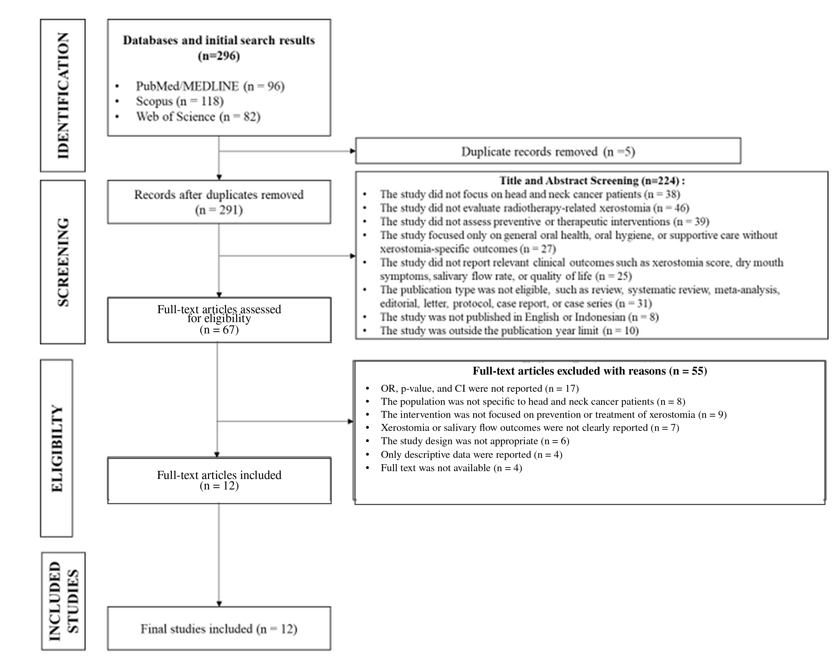
Figure 1. PRISMA flow diagram of the study-selection process.

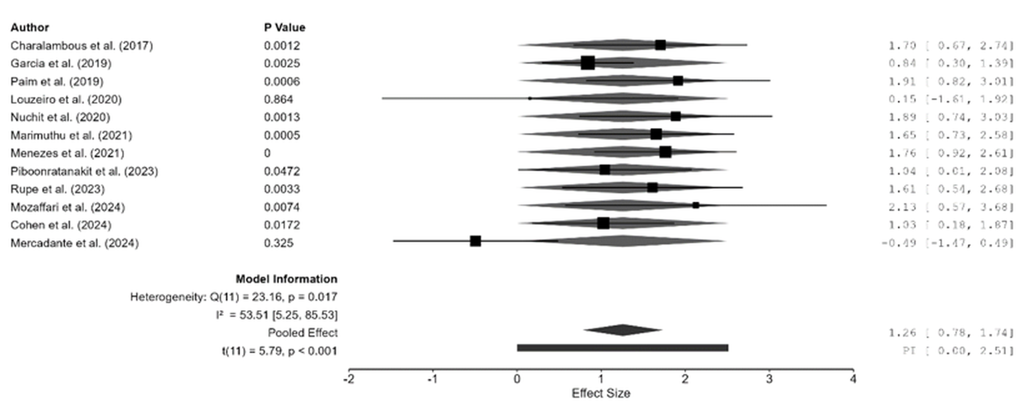
Figure 2. Forest plot of preventive and therapeutic interventions for radiotherapy-related xerostomia.

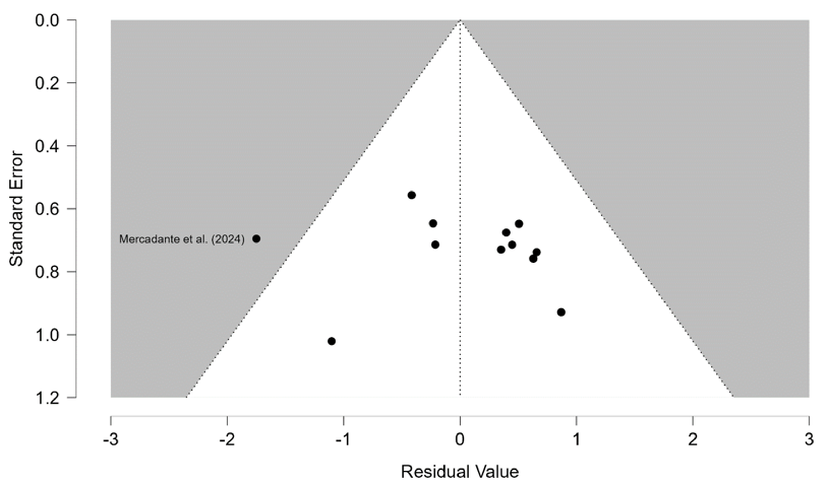
Figure 3. Funnel plot exploring publication bias and small-study effects.

